## SMTPConfig.uc.ini

This file is for the settings of your SMTP server. You DO NOT need to adjust this file to have it sending the reports as an email over your own SMTP server. It will look like the following:

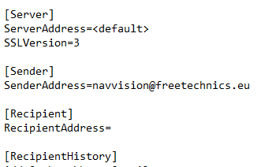

Figure 3‑1: SMTPConfig.uc.ini

This file will be generated the first time that you generate a report.

You will have to fill in your own information and add a few lines for your username and password. The next figure is an example. You need to adjust it to your own settings.

|  |  |
| --- | --- |
| Field | Explanation |
| ServerAddress | Address of the ships SMTP server or default |
| SSLVersion | 1-no authentication, 2=STARTTLS, 3=SSL/TLS |
| SenderAddress | The name you want as sender |

Table 3‑1: SMTPconfig